**Wei Liang** **SP17**

**CST 2309-E286**

**Lab#8**

**Prof. Sancar Avcioglu March 6, 2017**

**Lab#8**

**Internet Explorer:**

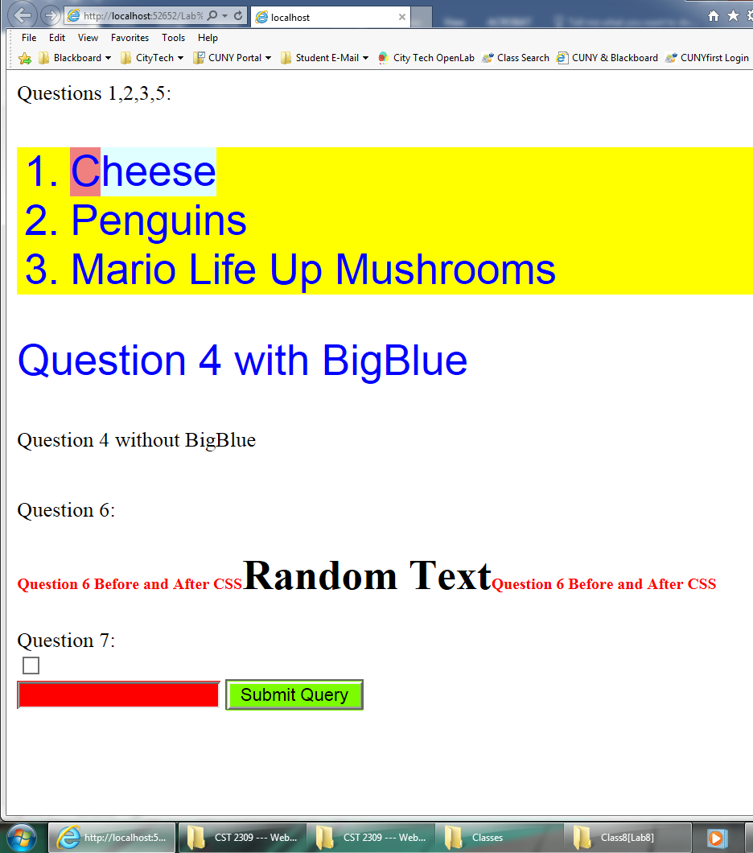

**Question 7: Checked**

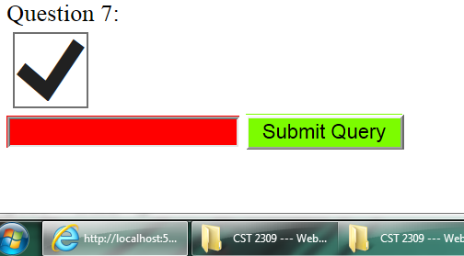

**Lab 8 Source Code:**

